***­­Binominal Distribution***

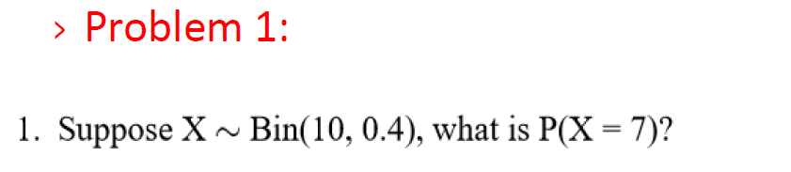

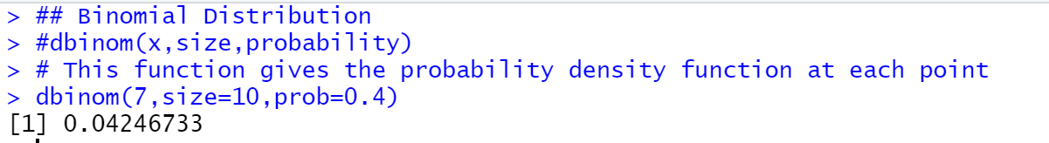

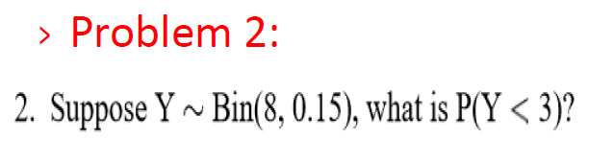

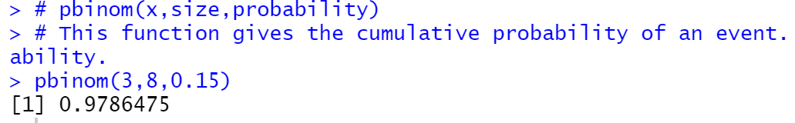

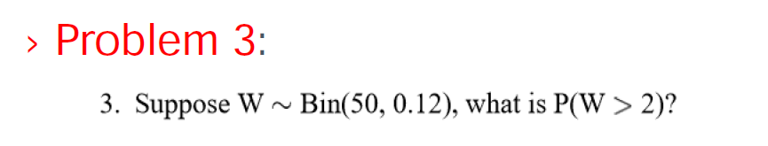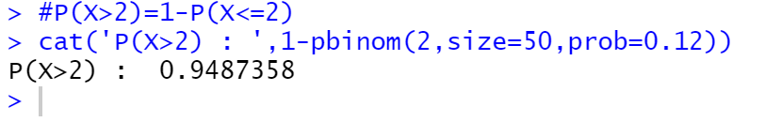

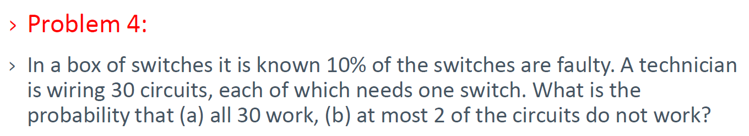c)at-most 2 of the circuit works : P(X<=2)

Probability of failure(i.e switches are not working) 🡪 10% (0.1)  
Probability of success(i.e switches are working) 🡪 90% (0.9)

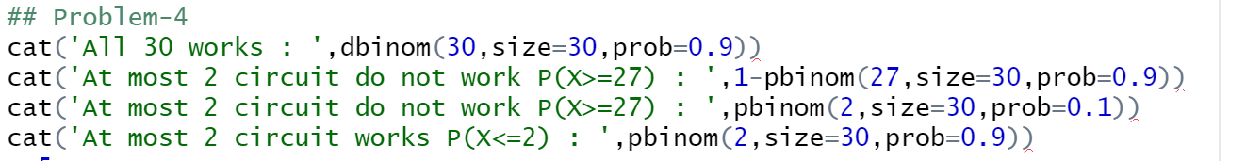

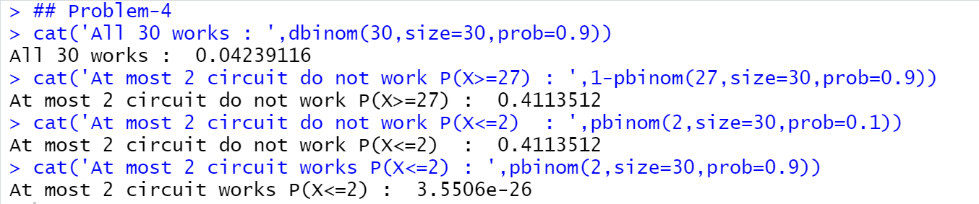

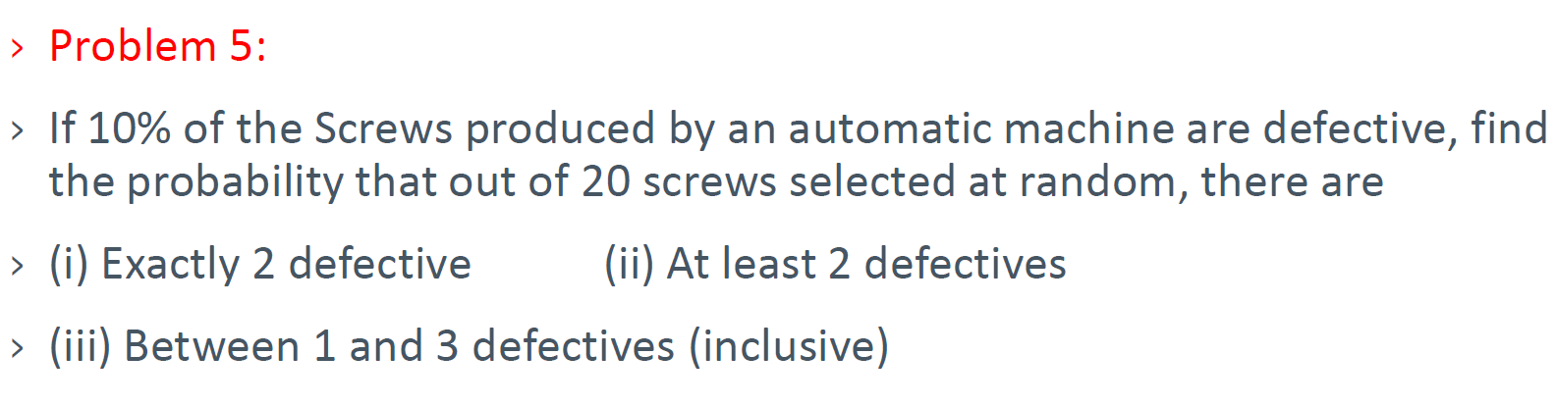  
Probability of success (i.e defective screws) 🡪 0.1

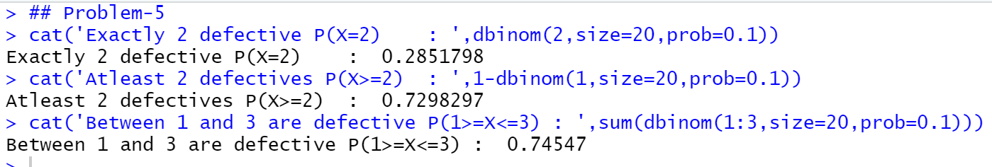

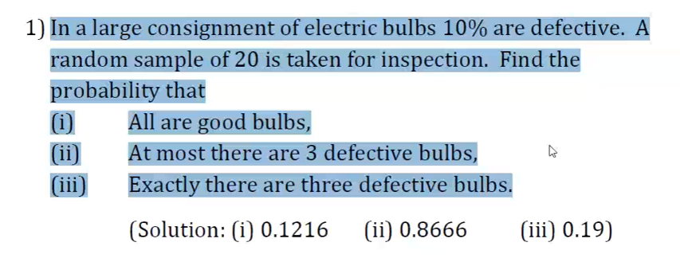  
Probability of defective 🡪 10% (i.e 0.1)  
Probability of good bulbs 🡪 90% (i.e 0.9)

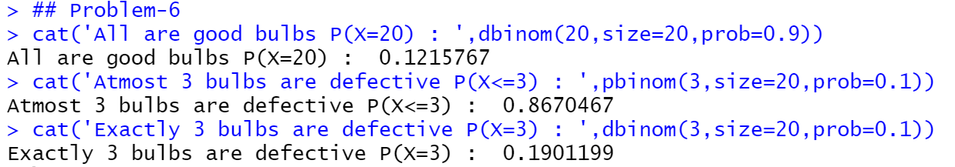

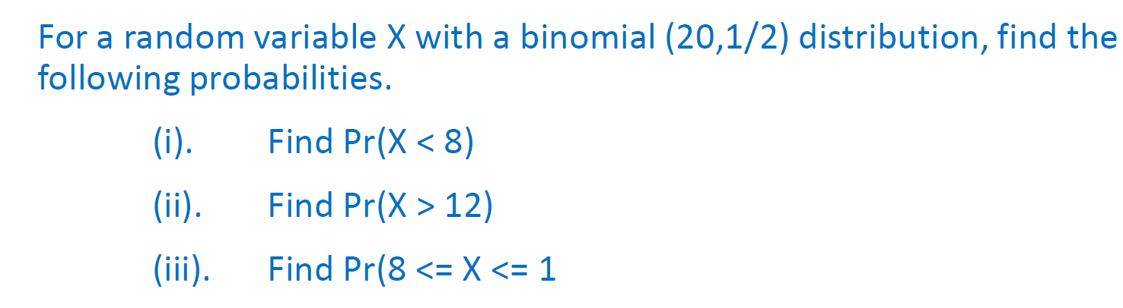  
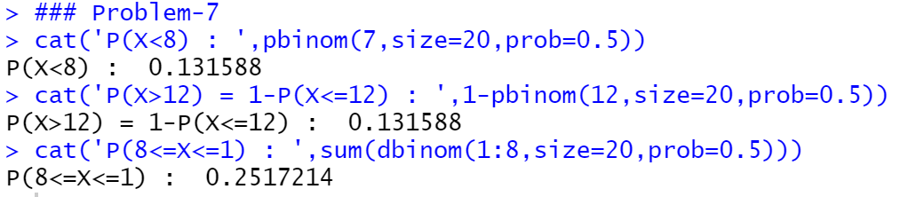

Poisson Distribution

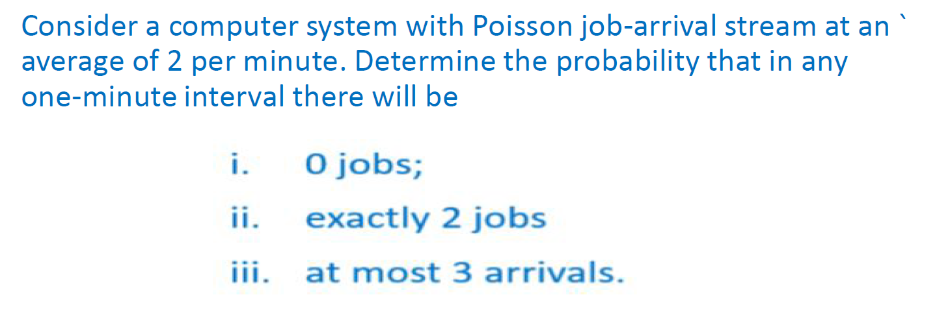  
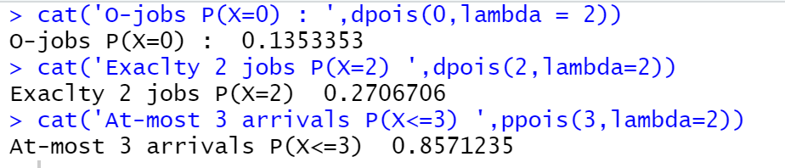



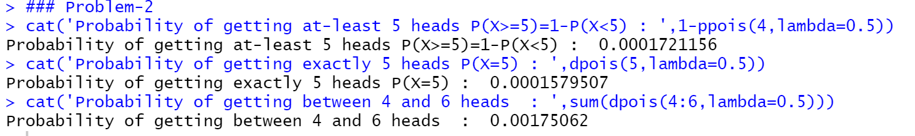

Normal Distribution

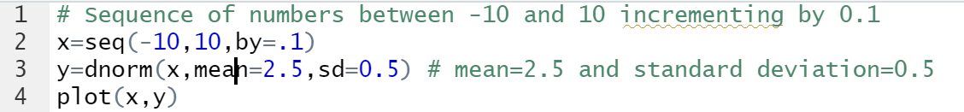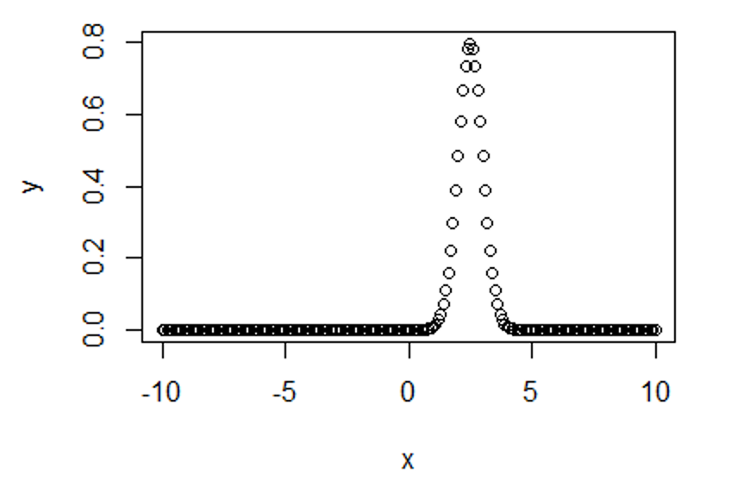

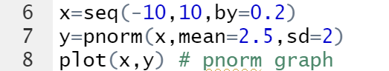

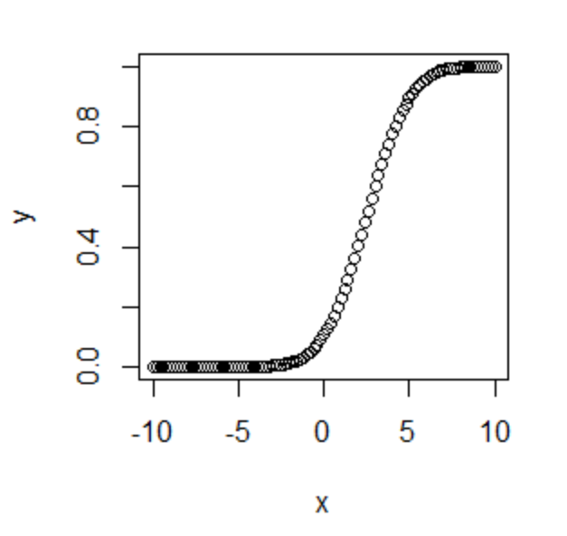

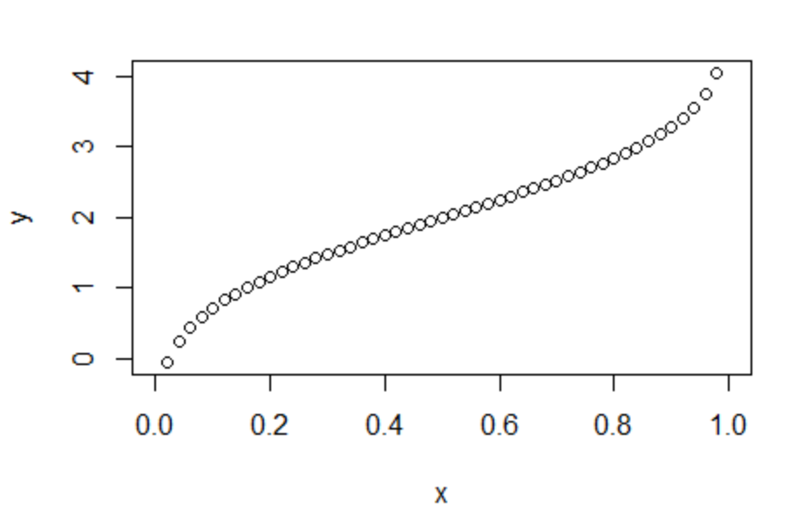

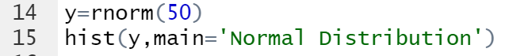  
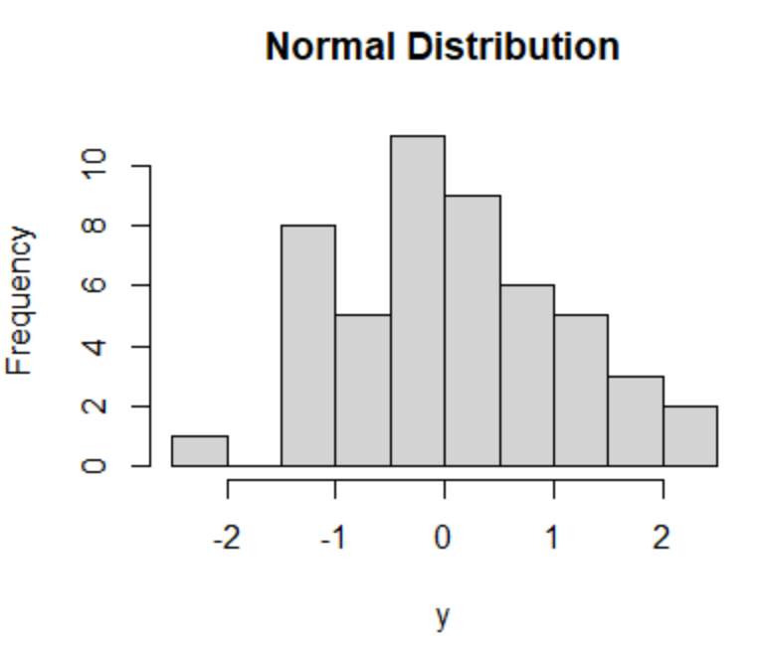

Program-1  
Draw a normal distribution with the mean=60 and standard deviation=15.

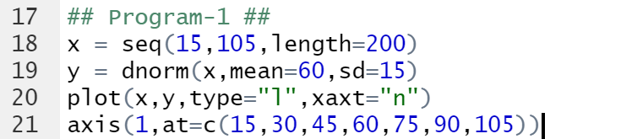

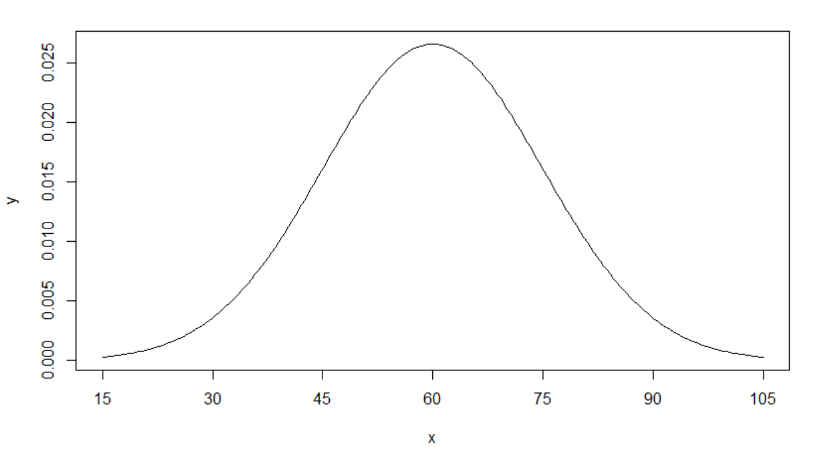

1) 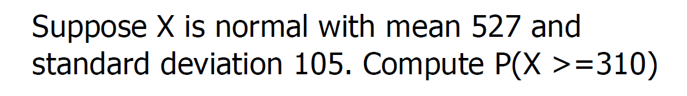  
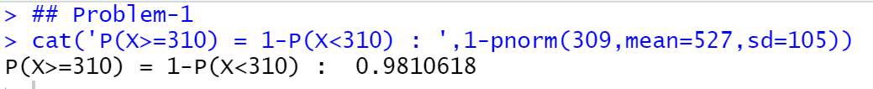

2)





3)

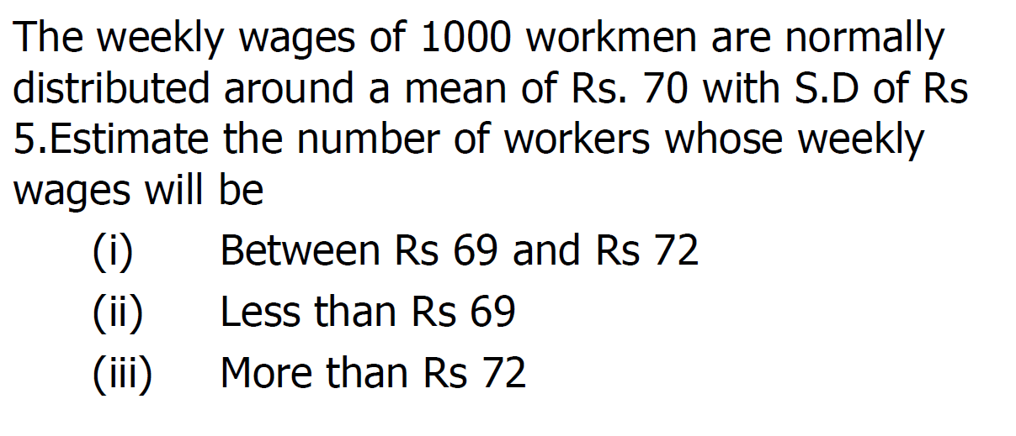

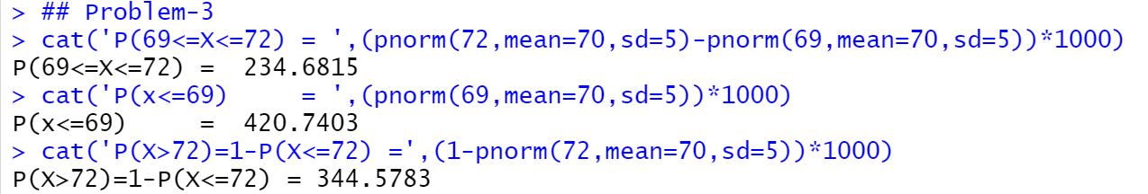

4) 